Project Design Phase
Solution Architecture
Date | 1 October 2026
Team ID
Project Name | Auto Ticket Classification using Flow Designer
Maximum Marks | 4 Marks

Solution Architecture:
Solution architecture is a complex process – with many sub-processes – that bridges the gap between business problems and technology solutions. Its goals are to:
- Find the best tech solution to solve existing business problems.
- Describe the structure, characteristics, behavior, and other aspects of the software to project stakeholders.
- Define features, development phases, and solution requirements.
- Provide specifications according to which the solution is defined, managed, and delivered.

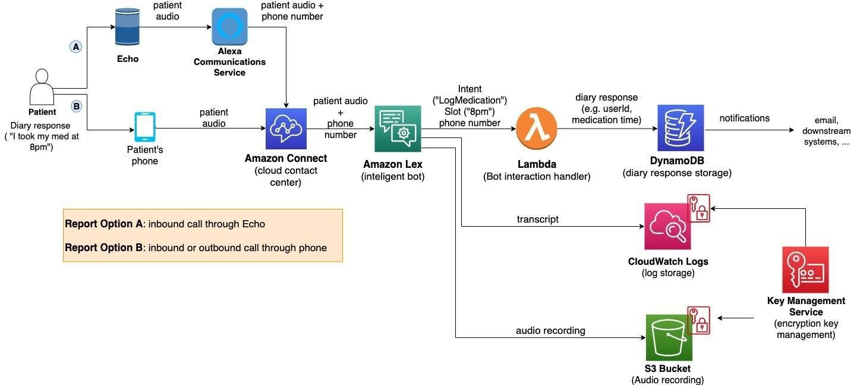

In the context of Auto Ticket Classification using Flow Designer, the solution architecture defines an automated, no-code workflow in ServiceNow that processes incoming support and incident tickets in real time. Upon incident creation, a Flow Designer trigger evaluates the ticket text (Short Description & Description), identifies the appropriate Category and Subcategory based on rule logic, automatically updates the incident fields, and hands the ticket off for normal incident processing.

Solution Architecture & Workflow Diagram:
Step 1: Ticket Creation
Incident/Ticket is created or submitted via ServiceNow Portal / Email / ITIL Form
↓
Step 2: Flow Designer Trigger
ServiceNow Flow Designer is triggered automatically upon record insertion on incident table
↓
Step 3: Ticket Details Evaluated
Flow condition logic inspects Short Description, Description, and Caller parameters
↓
Step 4: Category Selection
Matching rule identifies and assigns the primary Category (e.g., Software, Hardware, Network)
↓
Step 5: Subcategory Selection
Secondary rule logic selects the precise Subcategory based on the selected primary Category
↓
Step 6: Ticket Updated
Category, Subcategory, and Assignment Group fields are automatically updated on the incident record
↓
Step 7: Normal Incident Processing
Classified incident proceeds to specialized support teams for resolution & SLA tracking
Figure 1: Solution Architecture and Workflow of Auto Ticket Classification using Flow Designer

